Create a simple cloud software application for Library book reservation
system for SIMATS library using any Cloud Service Provider to demonstrate SaaS.

Aim :

To design and develop a cloud-based Library Book Reservation System for SIMATS Library using Zoho Creator, in order to demonstrate the Software as a Service (SaaS) model.

Procedure :

- Logged in to Zoho Creator using a Zoho account.
- Created a new blank application named SIMATS Library Book Reservation System.
- Designed a form to collect student and book details.
- Added required fields such as student name, register number, department, book title, and reservation date.
- Configured dropdown fields for department, book category, and reservation status.
- Created a workflow to automatically set the reservation status when a book is reserved.
- Generated reports to view reserved, issued, and returned books.
- Deployed the application on Zoho Cloud and accessed it through a web browser.
- Tested the application by entering sample book reservation records.

Output :
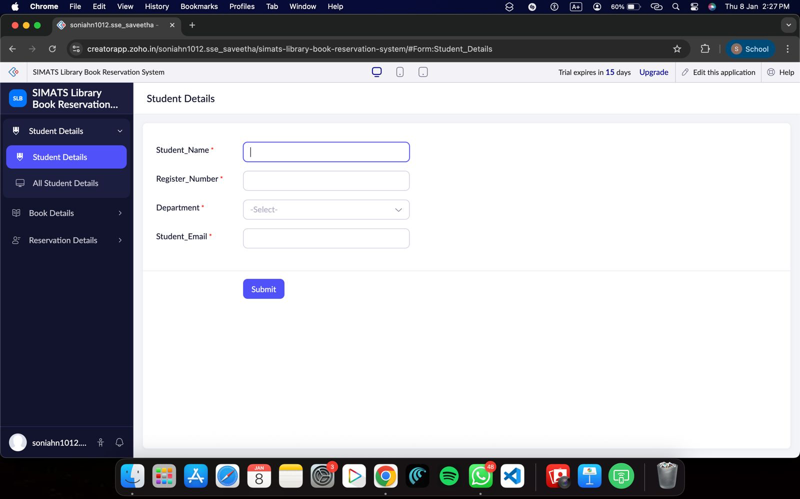
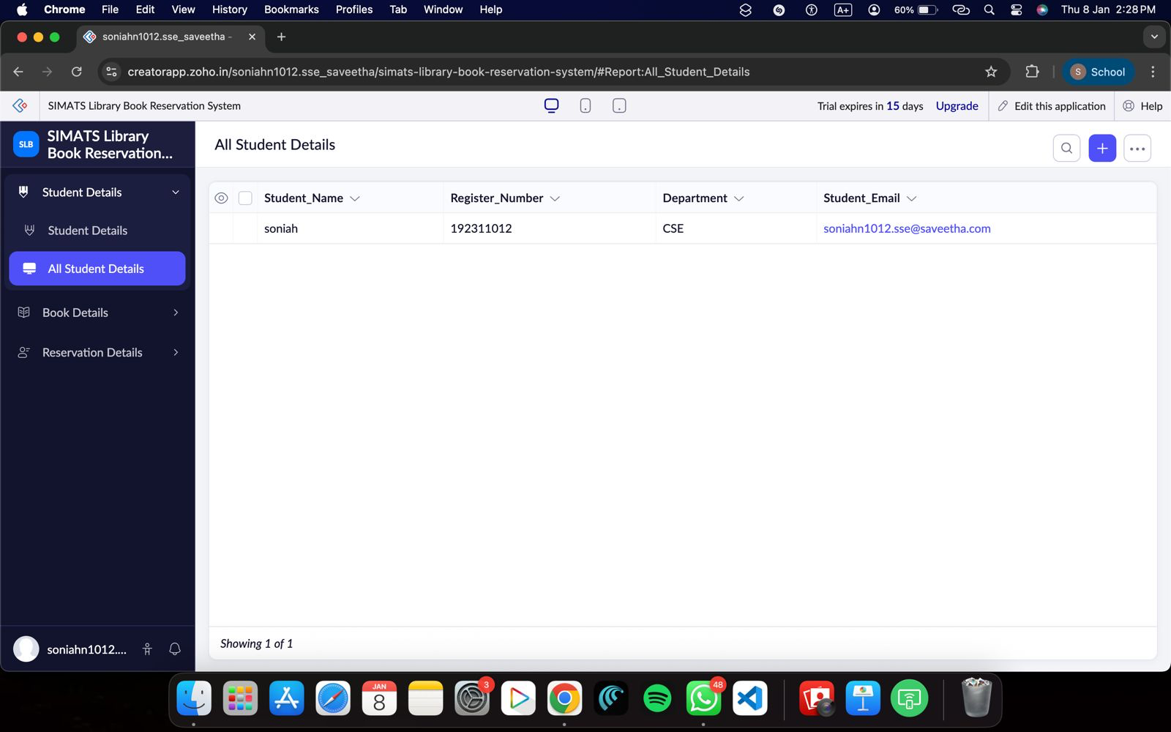

Book Details :

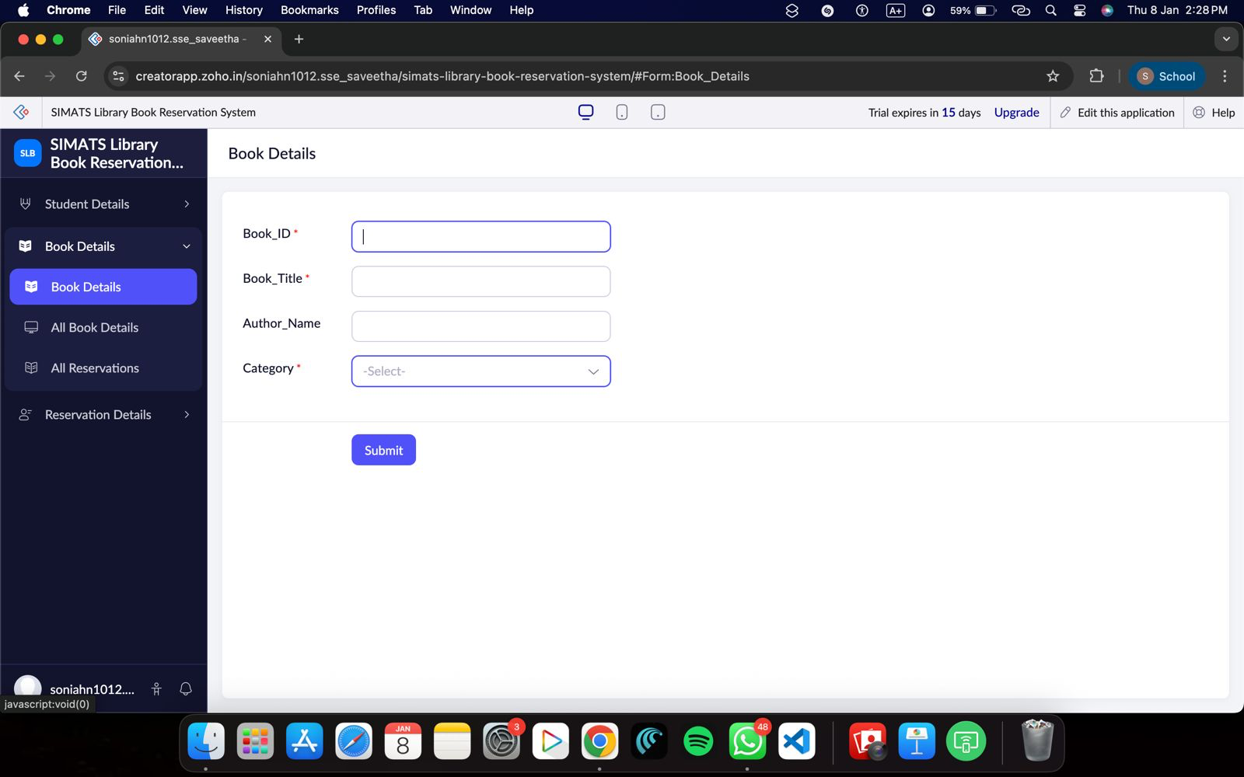

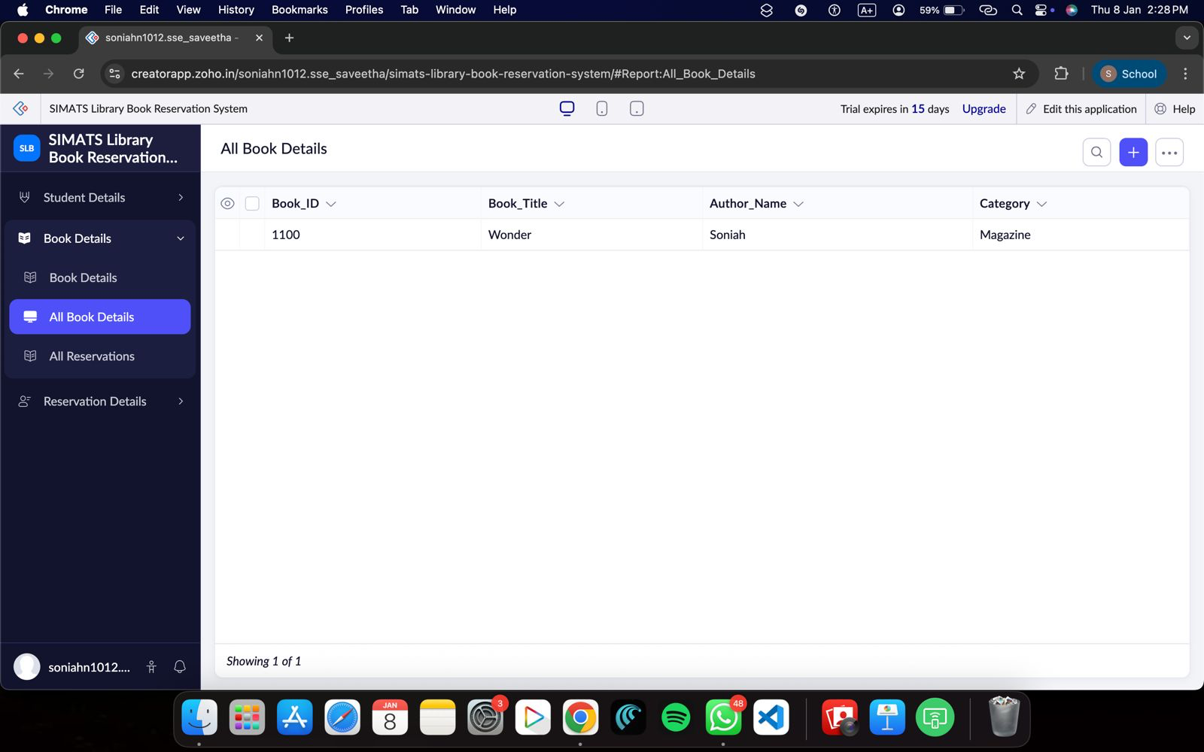

Reservation Details :
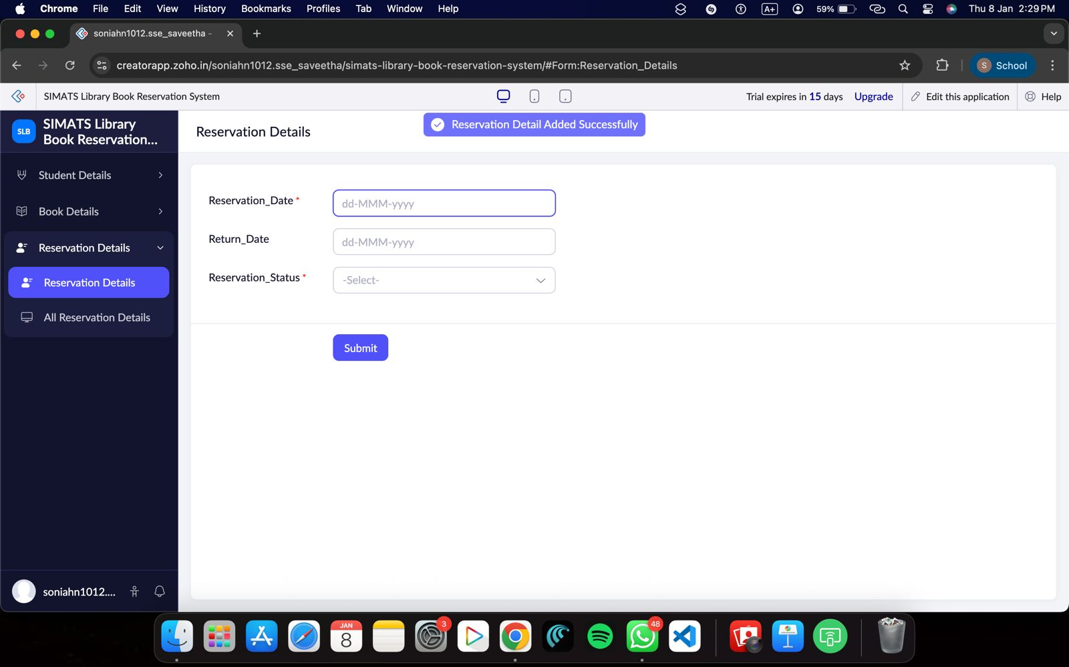

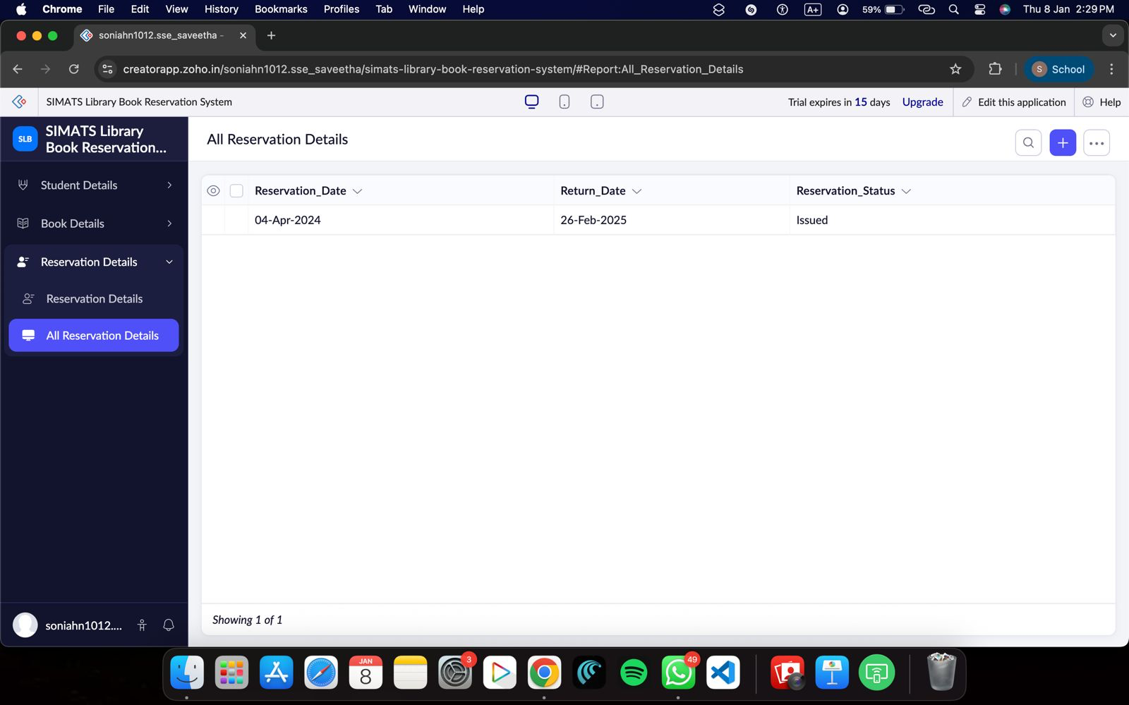

Result :

A cloud-based Library Book Reservation System for SIMATS Library was successfully created and deployed using Zoho Creator. The application allows students to reserve books online without local installation, thereby successfully demonstrating the Software as a Service (SaaS) model.

